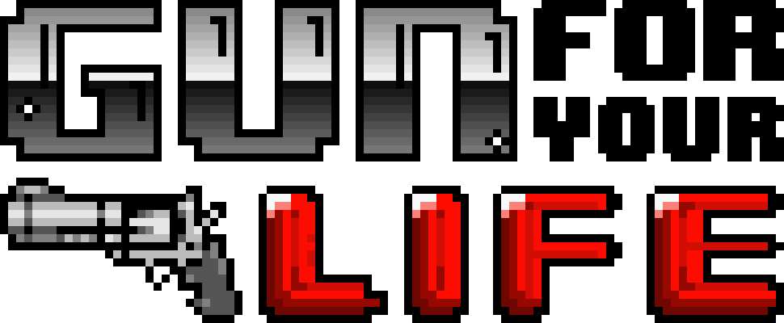

**GAME DESIGN**

**DOCUMENT**

FEEL GAMEPLAY

-ACTION -SHOOTER TOP DOWN

-ADRENALINE -WEAPONS

- MINDLESS FUN -COLlECTABLES +

UPGRADES

WEAPONS

- ONE HANDED

- TWO HANDED

- MELEE *

- SPECIALS *

* -SPECIAL SLOT

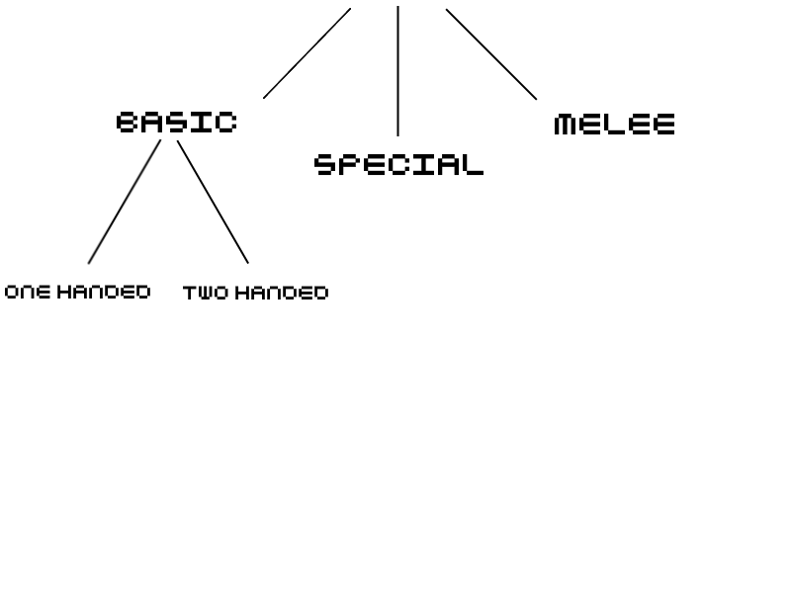 k WEAPONS

BASIC SPECIAL MELEE

+ Unlimited Ammo - Limited Ammo + No Ammo

- Require Reload + No Reload - Strike Cooldown

+ Ranged + Ranged - Melee

- Low to Mid DMG. + Mid to High DMG. + High DMG.

**Two Handed Vs. One Handed**

One Handed Two Handed

+ High Firing Speed + Higher DMG.

+ Faster Reload + High Accuracy

+ Dual Wield + High Penetration

- Lower DMG. - Slower Reload

- Low Accuracy - Low firing speed

- Low Penetration - No Dual Wield

PROGRESSION

The Player fights enemies to progress through the level and collects Money. At the end of the Level the Player will be rewarded and will be able to purchase Upgrades and Perks.

LEVEL PROGRESSION

Each Level is divided in Sub-Levels (Rooms), separated by locked doors. The Player must kill all Enemies in the Sub-Level in order to unlock the Door.



ROOM LAYOUT

Each Room contains Enemies, Chests and Covers. Some may have traps and hazards or secret Bonus Levels.

The Bonus Level contains more enemies and Chests. They are completely skippable, but may offer valuable Loot.



COVERS

In each level there are objects that can be used as covers. Breakable Covers have limited HP and can be destroyed.

CHESTS

Chests can be found in each Sub-Level. They can be looted and contain different weapons.

There are multiple Chest Types.

Each Chest Type drops different weapons.

Weapons are dropped randomly based on a percentage chance.

**Ex. Basic Chest Chances: Pistol – 50%**

**SMG – 50%**

RATING

At the end of each level the players will receive a rating based on the Money collected in that Level and the Time in which the level was completed.

*Based on the Level Rating the player will receive 1 to 5 STARS that are used to purchase Perks.*

TIMER

The Player is encouraged to finish each level as fast as possible. A Timer will keep track of how long it took the Player to finish a Level The faster the level is completed, the better the rating will be.

MONEY

Money is used by the player to purchase upgrades.

With each Death the player will lose a considerable amount of Money, thus the player is encouraged to stay alive.

Money can be obtained by killing enemies or breaking objects.

Money also influences the rating. The more Money the player obtained during a Level, the better the rating will be.

*Money act as Collectables*

COLLECTABLES

Collectables can be acquired by simply touching them. They will drop either when an enemy is killed, either when an object is destroyed.

*They will disappear after a short time.*

Collectables can be either Money or utility items like Health Kits.

GAME PROGRESSION

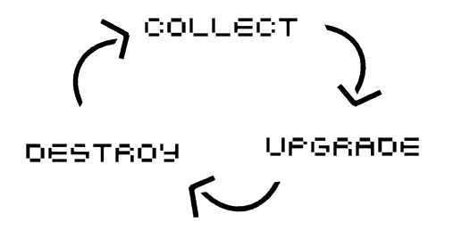

As you play, you will get access to better Gear and collect more Money and STARS to purchase Upgrades and Perks.

*Perks unlock new Abilities and alter the Player’s limitations.*

*Upgrades increase your STATS. (Ex. Health)*